Best Practices on AWS

For example : There is WordPress application which need to deploy on AWS Cloud

WordPress is a popular open-source blogging platform and content management system (CMS) based on PHP and MySQL. AWS customers deploy everything from simple blogs to high-traffic, complex websites.

We cover creating a simple deployment with a single server, which is a great starting point for those new to WordPress, or those looking for a cost-efficient solution for development and test environments.

We also look at to separate out the various components of a typical WordPress website in order to improve performance, resiliency, and cost efficiency, culminating in a highly available, multi-server, scalable architecture like the one illustrated below.

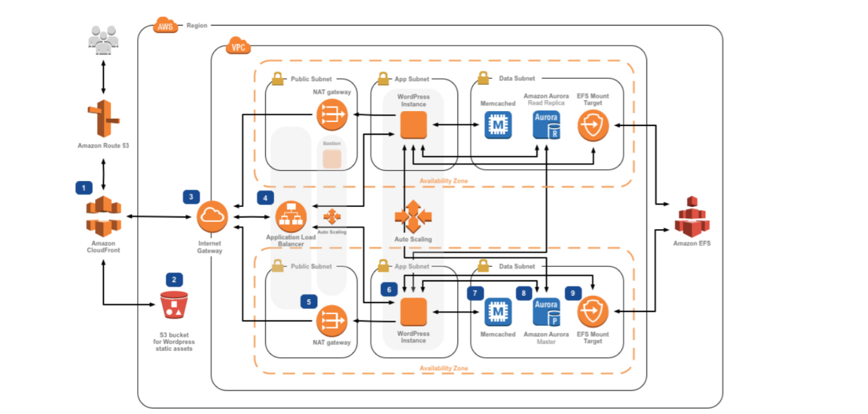The elastic deployment outlined in the whitepaper is very closely related to the [reference architecture](https://github.com/awslabs/aws-refarch-wordpress)for deploying WordPress on AWS, which is available on GitHub.